No Pipe? No Problem.
Why the Market Prices Superior Plus Like Propane Is on Its Last Legs?
Superior Plus Corp. (L): (TSX: SPB)
Current Price: C$6.71 CAD
Price Target: C$8.95 CAD (+33% return, +36% with the dividend)
Gideon Anthony
October 2026
US$ millions, except per share
Price (C$) | 6.71 | 22-Oct
Shares | 214.6 | Q226
MC | 1,044
Cash | 27 | Q226
Funded Debt | 1,527 | Q226
Leases | 138 | Q226
Preferreds | 260 | Q226
EV | 2,941
LTM Adj. EBITDA | 452 | Q226
EV/EBITDA | 6.5x

Trading Stats:
Insider Ownership | 0.4%
Institutions | 21.6%
Short % Float | 1.4%
Avg Volume (20d) | 528K
52-Wk Range | 6.06 - 8.86 | 9-Oct
Analysts (Buy/Hold) | 3 / 9 | 30-Oct

Description
Superior Plus is North America's largest propane distributor, headquartered in Toronto. It delivers propane to homes, farms and businesses across the U.S. and Canada, which made up about 75% of its US$464M of EBITDA in 2025. The other piece is Certarus, which compresses natural gas and trucks it to customers the pipeline network doesn't reach (oil and gas sites, factories, utilities and, since 2025, data centres). The company reports in US dollars.

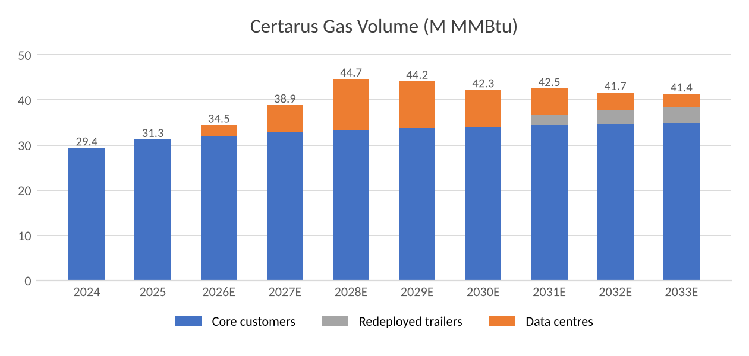
Data Centres, the Grid and the Gas Pipe
AI is pushing data-centre electricity use from about 415 TWh in 2024 to roughly 945 TWh by 2030¹. The problem isn't building the data centres, it's powering them. Grid connections in the main markets now take more than 4 years² and somewhere between 30% and 50% of the big projects planned for 2026 are expected to be delayed³. A finished data centre sitting without power loses money every month, so operators are paying for natural gas delivered by truck (about 4x the normal hub price⁴) to run generators on site until a pipeline shows up.
The Interesting Bit – A Temporary Pipeline for a Long-Term Problem
The market prices SPB like it is in a declining market. Even if you don't agree with my data-centre call, the stock is priced like propane is on its last legs: at C$6.71, my model only works if cash flow shrinks about 1% a year, forever. I initially planned to make the data-centre contracts the main price driver, but the model showed the stock is undervalued even without them (C$7.71 on the contracts already signed).
Pipelines are lagging behind what the AI hyperscalers are spending on data centres, and Certarus is the temporary solution to that long-term problem. On April 20, 2026 it signed a ~135 MW contract with a hyperscale site, roughly 2.5 years starting mid-2027, over US$300M of revenue and about 200 trailers⁵ (the stock jumped 10% that day). In May it started supplying a 60 MW site in Utah until the permanent pipeline is built⁶, and in October it was named as the company trucking gas to an Oracle data centre⁴. That makes six data-centre contracts and over US$350M of revenue since September 2025. It's a 2-3+ year opportunity, probably longer. Not forever, but real.
I believe Certarus volume grows about 13% in 2027 and 15% in 2028 as the 135 MW site starts up, then fades through 2033 as pipelines catch up. By 2028 capex starts to come down, debt is projected near 3x and buybacks could be reconsidered. The reasons analysts say Hold are short term, and I think they flip. My PT is C$8.95 (DCF, average of 0.5% terminal growth and a 6.5x EV/EBITDA exit, 7.09% WACC). The timeline: Q3 results on November 10-11, 2026, the 135 MW start in mid/late 2027, and the cash flow and leverage turn in 2028.
What's more, Superior is backing this with its own money: a US$100M order for new Hexagon trailers in July⁷. When an analyst asked on the Q2 call if the data-centre work targets returns of at least 15%, the CFO said you could assume that⁸. The bear case is that these are short contracts that need brand new trailers, and on signed contracts alone that's fair (C$7.71, versus C$8.21 if they had never taken the work). But the trailers last a long time, and management was upfront that the first contract won't earn the whole return; the rest has to come from extensions, new jobs or moving the trailers to other customers⁹. That is exactly what I'm betting on.
The Numbers in Plain English
"...the economics won't be completely guaranteed by the initial contract..."⁹
Grier Colter, CFO, Q2 2026 earnings call
At June 30, Superior owed US$1,638M after cash, which is 3.6x its yearly EBITDA¹⁰. Capex jumped from about US$160M to US$230M this year to buy trailers and buybacks are paused, which is why RBC downgraded the stock in August¹¹. What this means in plain English is that once interest and both sets of dividends are paid, I estimate about US$87M is left over to pay down debt in 2027 and about US$165M in 2028. That gets leverage to around 3.0x in 2028, which is management's own target (my model runs about 0.2x better than their guidance, so I would call it "around" 3.0x, not below it). The one thing that would change this is if they redeem the US$260M preferred shares with new debt, which management says adds about 0.5x.
US$ millions | H2 2026E | 2027E | 2028E | 2029E | 2030E
Cash left to repay debt | (91) | 87 | 166 | 163 | 157
Net debt, year end | 1,729 | 1,641 | 1,475 | 1,313 | 1,156
Net debt / EBITDA | 3.7x | 3.3x | 2.8x | 2.5x | 2.3x
Management guidance | ~3.9x | ~3.5x | 3.0x

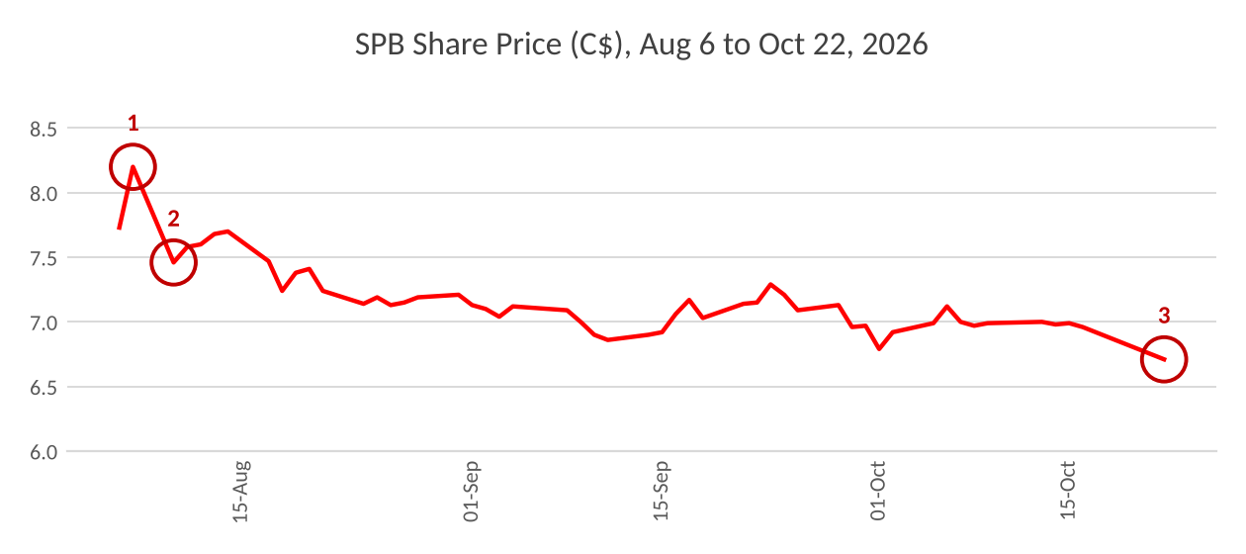
1) Q2 results come out on August 6 and the stock goes to C$8.20. 2) RBC downgrades to Sector Perform on August 10 (C$9 target) and the stock drops 9% in a day¹¹. 3) TD cuts its target on October 22 and the stock closes at C$6.71¹². The big drop came on the downgrade, not the results, and the downgrade reasons are the short-term ones I think flip in 2028.
Scenarios
 | Bear (30%) | Base (50%) | Bull (20%)
Exit multiple / terminal growth | 5.8x / 0% | 6.5x / 0.5% | 8.0x / 1.0%
Value per share (C$) | 2.69 | 8.95 | 15.15
Return with dividend | -57% | +36% | +129%

Bear: the 135 MW start slips to 2028, no new contracts and a price war after 2030. Base: contracts run as disclosed, a gentle fade, and 40% of trailers find new work. Bull: the bottleneck lasts longer, more wins, and the market pays a Suburban-like multiple. Weighting them 30/50/20 gives C$8.31 (+24%).
What Would Change My Mind
- The 135 MW start slips into 2028 (watch the Q3 and Q4 2026 calls).
- Certarus EBITDA falls under US$3.4 per MMBtu two quarters in a row (the model needs about US$3.7-3.8).
- Capex is still above 7.8% of revenue in 2028 (the value drops to C$6.96).
- No new data-centre awards by 2028, or trailers sitting parked after contracts end (the value drops toward C$7.71).
One red flag is worth watching. Two at the same time and I think the market is right.
Appendix
DCF summary, Base case (US$ millions)
 | 2026E | 2027E | 2028E | 2029E | 2030E | 2031E | 2032E | 2033E
Certarus volume (M MMBtu) | 34.5 | 38.9 | 44.7 | 44.2 | 42.3 | 42.5 | 41.7 | 41.4
Adjusted EBITDA | 473 | 491 | 531 | 523 | 510 | 505 | 497 | 491
of which Certarus | 133 | 144 | 169 | 160 | 147 | 141 | 131 | 123
Capex incl. leases | 231 | 233 | 190 | 193 | 194 | 198 | 200 | 203
Unlevered FCF | 188 | 204 | 281 | 273 | 263 | 257 | 250 | 243
WACC 7.09% (risk-free 4.96%, beta 1.04, ERP 5.0%, cost of debt 6.85% pre-tax, preferreds 7.25%). PV of 2026-33 cash flows US$1,321M; terminal value about 60% of EV. Value per share C$9.15 (Gordon) and C$8.75 (6.5x exit).
Comparables, LTM, leases taken out (US$ millions)
 | EV | LTM EBITDA | EV/EBITDA | Net Debt/EBITDA
Suburban Propane (SPH) | 2,401 | 277 | 8.7x | 4.4x
Star Group (SGU) | 571 | 156 | 3.7x | 0.9x
Clean Energy Fuels (CLNE) | 408 | 66 | 6.2x | 1.4x
Median |  |  | 6.2x | 1.4x
Superior Plus (SPB) | 2,804 | 404 | 6.9x | 3.7x
None of these is a perfect match (Suburban is closest), but they tell me SPB isn't cheap on multiples. The case is the cash flow, which is why I used SPB's own 6.5x for the exit and not a peer multiple.

Sources
1. IEA, Energy and AI (2025).
2. JLL, Global Data Center Outlook 2026.
3. Network World, July 27, 2026.
4. AP via Transport Topics, October 9, 2026 (Oracle; East Daley delivered-gas estimate).
5. Business Wire / Certarus, April 20, 2026; BNN Bloomberg, April 20, 2026 (share reaction).
6. Certarus / Pipeline & Gas Journal, May 13-14, 2026.
7. Hexagon Agility, July 6-7, 2026.
8. Superior Plus Q2 2026 earnings call transcript, p.8.
9. Superior Plus Q2 2026 earnings call transcript, p.22.
10. Superior Plus Q2 2026 results package, p.3 and Net Debt reconciliation p.34.
11. MT Newswires / finwire, August 10, 2026 (RBC; quoted, full note not reviewed).
12. MarketBeat, October 2026 (TD target cut; consensus); StockAnalysis price history and statistics (Sep-Oct 2026).
Personal research project, not investment advice. I hold no position.

